Ordered Set

1) Definition
An Ordered Set stores elements in sorted order while supporting efficient dynamic operations.

2) Core Operations & Complexity
Operation | Time Complexity | Description
Insert | O(log n) | Add element while maintaining order
Delete | O(log n) | Remove element
Search | O(log n) | Check existence
Predecessor | O(log n) | Largest element < x
Successor | O(log n) | Smallest element > x
Java Implementation:
- TreeSet / TreeMap
- Implemented using a Red-Black Tree (self-balancing BST)

3) Uses / Advantages
- Maintains sorted order automatically
- Efficient insertion and deletion
- Quickly find nearest elements (next greater / smaller)
- Useful for dynamic datasets
- Helpful in window-based problems
- Alternative to heaps when ordering matters

4) Variants / Types
- Ordered Set
- Ordered Map
- Multiset (in some languages)
- Implemented via balanced BST structures

5) Benefits in Algorithms
- Handles ordering constraints cleanly
- Ideal for dynamic sliding window with sorting
- Good substitute for monotonic structures when rules are complex
- Supports range queries and neighbour queries efficiently

6) Pattern Recognition — When to Apply
Look for keywords such as:
- “closest element”
- “within window k”
- “value within range”
- “kth smallest in subarray”
- Dynamic add/remove operations
- Continuous queries on changing data
- “difference ≤ t”
- Need predecessor/successor quickly

7) Common LeetCode Problems Using Ordered Set
- 220 — Contains Duplicate III
- 480 — Sliding Window Median
- 295 — Find Median from Data Stream
- 1438 — Longest Continuous Subarray With Absolute Diff ≤ Limit
- 1649 — Create Sorted Array through Instructions
- 218 — The Skyline Problem
- 729 / 731 / 732 — My Calendar I / II / III
- 855 — Exam Room
- 981 — Time Based Key-Value Store
- 327 — Count of Range Sum
- 945 — Minimum Increment to Make Array Unique
- 1888 — Minimum Number of Flips to Make Binary String Alternating

8) Standard Sliding Window Approach with Ordered Set
Goal: Maintain ordered elements in current window
Steps
- Maintain an ordered set for current window elements
- For each new element:
  - Query floor(x) and ceiling(x) for bounds
- Add the current element
- If window size exceeds k → remove leftmost element
- Check required condition (range, difference, etc.)
Time Complexity:
O(n log k)

9) Useful Methods (Java TreeSet)
Method | Meaning
ceiling(x) | Smallest element ≥ x
floor(x) | Largest element ≤ x
higher(x) | Smallest element > x
lower(x) | Largest element < x

🔹 What is an Ordered Set?
An Ordered Set keeps elements sorted at all times and is typically implemented using a self-balancing Binary Search Tree (BST) such as a Red-Black Tree.

Binary Search Tree Ordering
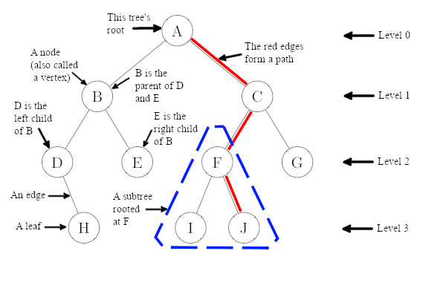
4 BST Property
For every node:
- Left subtree → values smaller
- Right subtree → values greater
- Inorder traversal → sorted sequence
Example (inorder):
5, 10, 15, 20, 25, 30, 35

⚖️ Self-Balancing Tree (Red-Black Tree)

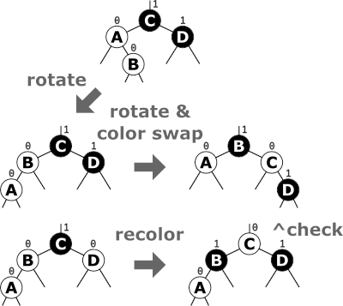

4
A normal BST can become skewed (O(n)).
A Red-Black Tree keeps height ≈ log n using rotations and coloring rules.
Key properties:
- Root is black
- No two red nodes adjacent
- Every path has same number of black nodes
- Tree remains approximately balanced
👉 Java TreeSet and TreeMap use this structure.

➕ Insertion Example (Step by Step)
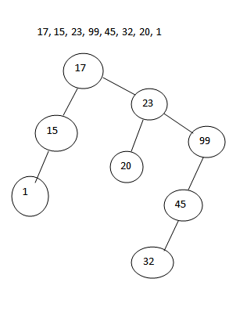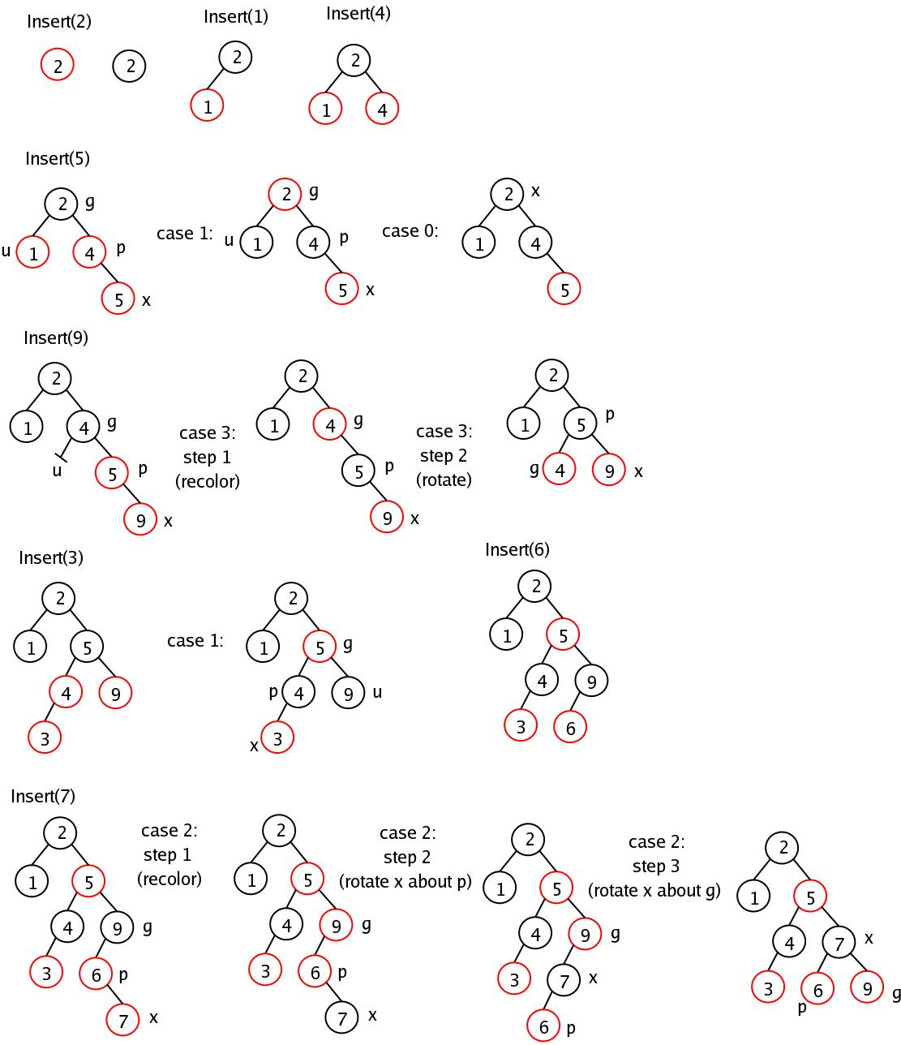

4
Insert sequence: 10 → 20 → 5 → 15 → 25
Result stays ordered automatically.
Time: O(log n)

🔍 Predecessor & Successor (Neighbor Search)

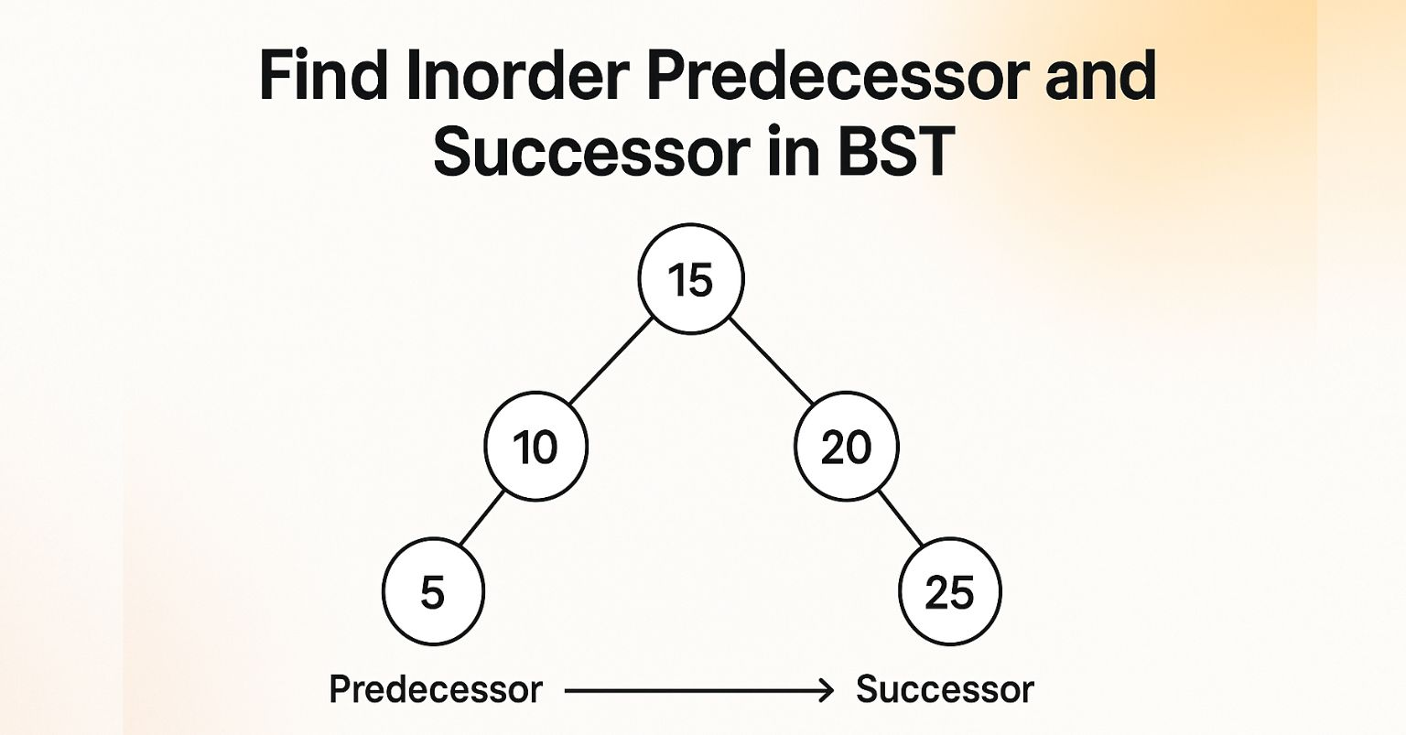

4
For value x:
- Predecessor = largest value < x
- Successor = smallest value > x
In ordered sets:
- floor(x) → predecessor or equal
- ceiling(x) → successor or equal

🪟 Ordered Set in Sliding Window Problems
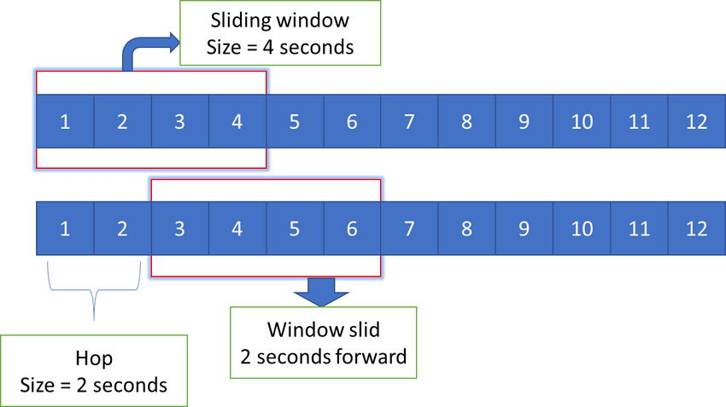
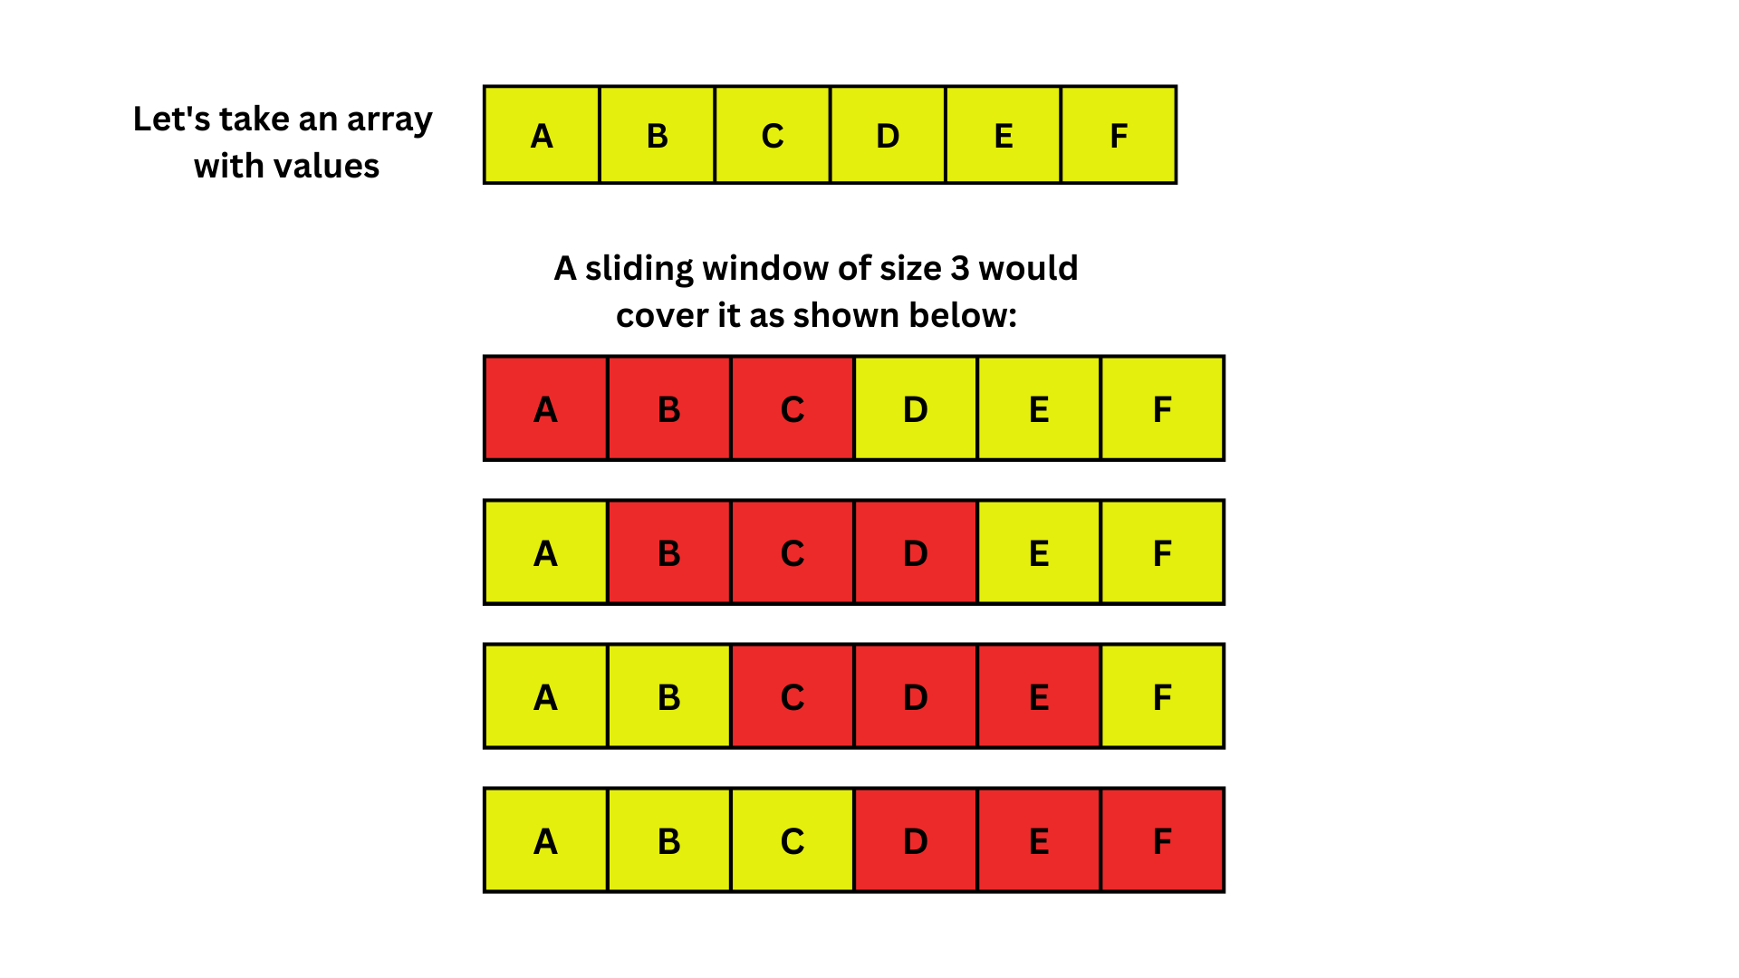

4
Maintain a sorted structure for the current window.
Typical Flow
- Add new element to ordered set
- Query neighbors (floor / ceiling)
- Check condition (range, diff, etc.)
- Remove element leaving window
Time: O(n log k)

Why Ordered Set Works So Well
✅ Always sorted
✅ Fast insert/delete/search
✅ Instant nearest element queries
✅ Handles dynamic data
✅ Ideal for range and window problems

Java
TreeSet<Integer> set = new TreeSet<>();
set.add(x); // insert
set.remove(x); // delete
set.contains(x); // search
set.floor(x); // ≤ x
set.ceiling(x); // ≥ x
set.lower(x); // < x
set.higher(x); // > x

